### Our client Requirement

1. The user interface should be like the interface of “Uber”, as the picture below:

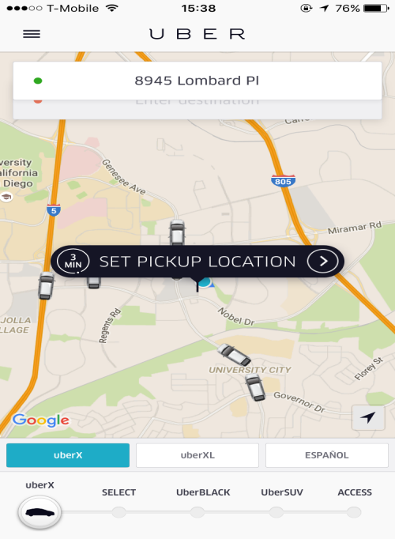

1. The app should be able to keep track of MTS bus, and also the UCSD campus loop shuttle
2. The app need to access to the user’s current geographical location
3. Users can use this app in two ways:

i). Choose a bus route/UCSD campus loop shuttle which he/she wants to take, and the app tells him/her the real time schedule of that bus route/shuttle.

ii). Enter a destination. The system should tell him/her which bus routes/shuttle to take, finding the nearest bus station, and remind the user when he/she should leave the current location in order to catch next closest available bus/shuttle.

1. Since user can choose to walk or ride a bicycle to the bus station, the system should alert the user when he/she should leave their current location based on the way he/she will head to the bus station. Since walking to the bus station is slower than riding a bicycle, the system will alert the user to leave the current location earlier if he/she choose to walk.
2. Addition features: The application would be to some how check how many are currently waiting for the bus, to provide the most meaningful and helpful experience to the user.